**Reading Ear Notching**

**Competency:** FL DOE 06.02- Analyze commercially important livestock breeds in Florida.

**Directions:** Read the article on <https://surechamp.com/blog/2016/06/29/how-to-read-pig-ear-notches/> as well as watching the accompanying video found on the page (Show Pig: How To Read Ear Notches). After reading, please read through the worksheet and answer the accompanying questions.

1. After reading the article and watching the video, please explain the process of identifying a pig by ear notching in your own words. Your explanation should be 3-5 sentences and should be simple enough that you could teach it to another person.

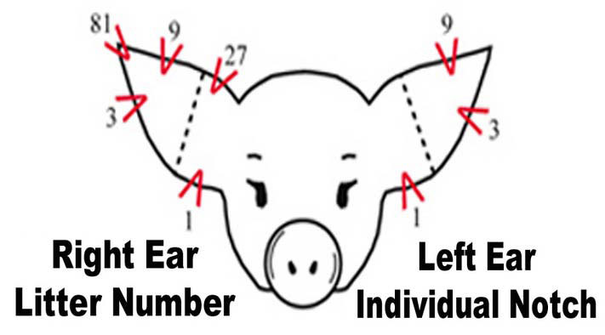

Below are examples of ear notched piglets. Using the inforation above and from the article, please indicate the litter number and individual number for each pig below.

1. 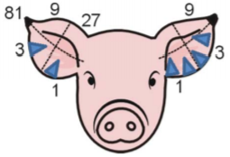 Litter Number: Individual Number:
2. 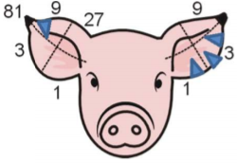 Litter Number: Individual Number:
3. 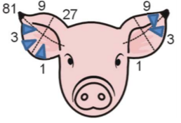 Litter Number: Individual Number:
4. 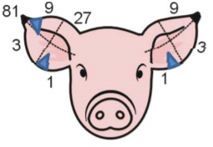 Litter Number: Individual Number:
5. 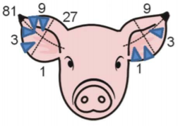 Litter Number: Individual Number:

Recap, Review- Please answer the following questions in complete sentances.

1. Why is ear notching commonly used for identification purposes?
2. In a large scale production facility, why would it be extremely important to know a pigs litter number?
3. If ear notching represented a pigs first and last name, which section would be the pigs first name? Where would it be located?
4. If ear notching represented a pigs frist and last name, which section would be the pigs last name? Where would it be located?