Piglet Identification and Care Practices
Competency: FL DOE 06.02- Analyze commercially important livestock breeds in Florida.
Directions: Answer the questions below based on the reading and research from online sources such as thepigsite.com and pork.org. Answer all questions in complete sentences.

It is easy to identify an individual breed of pig; however it is extremely difficult to identify an individual pig within a large group without proper identification methods. Ear tags, ear notching, and tattoos are common identification methods used by farmers in America. Typically, identification methods are fulfilled when the piglet is still very young to aid in fast healing, easy observation, and minimal pain. Other procedures that piglets go through include castration, tail docking, and clipping of needle teeth. Each procedure has safety risks and benefits associated with them and it is up to the individual farmer to carry them out in their piglets.

Please explain each method of identification and the pros and cons of each.
Identification Methods
Tattooing:
Ear Notching:
Ear Tags:

Please explain the purpose and procedure for each management practice; include the pros and cons or each.
Management Practices
Castration:
Clipping needle teeth:
Tail docking:

Below are tools used for completion of the practices above; please match each photo with the name of the tool it belongs to and which practice it is used in.


- Tool name: 2. Tool name:
Purpose: Purpose:

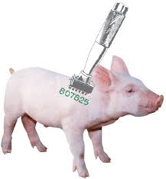


- Tool name: 4. Tool name:
Purpose: Purpose:

Now that you have conducted research on these procedures and have heard opinions for both sides, please come up with your own stance on the subjects. Answer each question in 2-3 complete sentences.
- Make a list of management practices you agree with, as well as ones you disagree with.

- How does incorporating these procedures affect overall herd health?

- Which method of identification is the most effective? Why?

- Which management practice do you find the most important? Why?

- Which management practices do you find the least effective?

